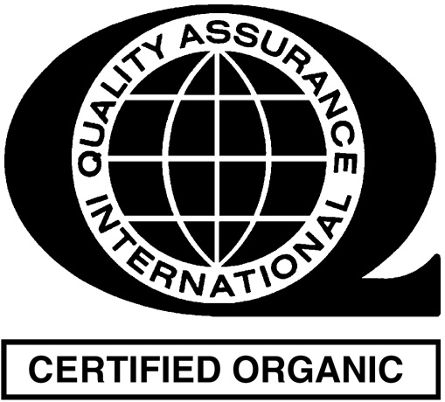
Organic Input and Ingredient
Commercial Availability Information
Use this form to document commercial availability information for non-organic agricultural ingredients or non-agricultural ingredients (when applicable) used in organic food production when an organic type is not commercially available.
Date Completed:
Name of Person Completing This Form:
Name of Entity Seeking New or Renewed Certification:
Name of Non-Organic Ingredient:

List Ingredient Suppliers Contacted  (At least three sources must be contacted annually) | Date Contacted | Does this supplier carry organic ingredients? | Method of Contact | Please check at least one reason | Provide additional justification  (e.g., explain which specific quality aspects are not met by an organic equivalent)
1. |  | Yes  No | Phone  Email  Fax | Quality  Quantity  Form
2. |  | Yes  No | Phone  Email  Fax | Quality  Quantity  Form
3. |  | Yes  No | Phone  Email  Fax | Quality  Quantity  Form
Please explain what actions, other than attempts to source the preferred ingredient, are being taken to further identify an equivalent organic ingredient. Examples may include entering into contracts with suppliers to provide specified products in the future R&D trials of organic ingredients.
Please note the following resources that may be helpful when searching organic ingredients:
- QAI website search for Certified Clients: www.qai-inc.com
- The Organic Trade Association’s “Organic Pages Online”: www.theorganicpages.com
- Accredited Certifiers Association’s “606Organic” website:www.606organic.com
- List of Certified Operations on the National Organic Program’s Website: http://apps.ams.usda.gov/nop/

Agricultural Ingredient: Any agricultural ingredient allowed to be used in products labeled as “Organic” according to USDA 7CFR Part 205.606 & CAN/CGSB-32.311- 2006.6.1(a)
Non-Agricultural Ingredient: Any non-agricultural ingredient allowed according to USDA 7CFR Part 205.605 (when required per annotation) & CAN/CGSB-32.311- 2006.6.1(a) to be used in products making an organic claim when the ingredient is not commercially available as organic.
Commercially Available:” is defined as the ability to obtain an ingredient in an appropriate form, quality, or quantity to fulfill an essential function in a system of organic production or handling. Cost is not an allowable reason for using a non-organic form of an input.

